Yes, electric resistance heating in Ontario is more expensive than natural gas heating but wait, there’s more…
Electric resistance heating is about 3 times more expensive than natural gas in Ottawa at the moment. But if you use a heat pump they lower the amount of electricity required by about 2.5 times. Still electricity is more expensive even with a heat pump but wait there’s more…
Net metered solar power has a lifetime cost about 2/3rds the average cost of grid supplied electricity. So combining a heat pump with solar power makes electric heating less expensive than natural gas heating. But I have introduced some new terms to “unpack”. Net metered and lifetime costs.
What are lifetime costs of solar panels? Well to compare the costs of solar supplied electricity to grid supplied electricity one is tempted to say solar power is free. Yes, that’s true. What is not free is the collection device (solar panels, inverters, wiring, controls etc.). So in order to compare grid supplied electricity we can compare the costs of solar panels over their life (approximately 25 years) to the cost of the power that those solar panels would generate over the 25 years. This works out to solar power is about 2/3rds the cost of grid supplied electricity. In terms of the unit costs that we are used to grid supplied electricity varies a little from year to year but in Ontario is currently about 12 cents per kWh and the lifetime unit rate of solar power is about 8 cents per kWh.
Next what is Net Metering? Net metering means using credits on the electricity bill for the excess energy solar panels generate in the long spring and summer days and using these against the low energy deficits in the winter when solar panels generate little power. Think of especially the short grey days of November, December and January. The goal is to put enough solar panels on the roof to generate as much power as a house or building requires over the entire year. In Ontario excess power production is not paid back to the home-owner so we try to design the solar production to be just a little under the average annual energy requirements of the building.
But wait there is more…
Scientists believe the Green House Gases (GHG) that are emitted by burning fossil fuels (coal, oil and natural gases) have changed the constitution of the atmosphere enough to cause a rise in global temperatures around the earth. This is not good. There are all sorts of consequences to such a large change. Droughts in some areas of the world, floods in others, hurricanes, typhoons, tornadoes, melting polar ice caps, stress for plants and animals and even extinctions and a whole list of related issues. Plus, there is a natural limit on the amount of fossil fuels that are available. It’s not immediate but we do need to transition off fossil fuels eventually and as we use more and more fossil fuels they deplete and become harder to find new supplies which of course makes them more expensive. For these reasons and a few more we should use less fuels that produce Green House Gases (fossil fuels).
Here is a graph of the GHG emissions of various fuels used to heat (spaces and water) in Ontario relative to natural gas which is burned at 92% efficiency (a common efficiency for condensing furnaces, and boilers).
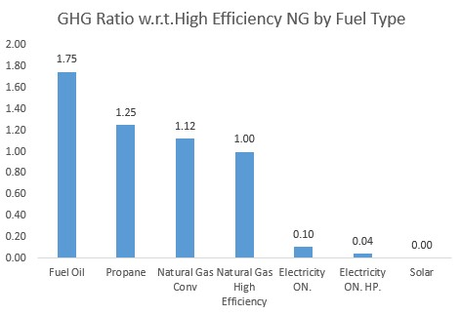
The fuels are likely familiar to you with the exception of Natural Gas Conv. This just means natural gas that has been burned in a conventional efficiency heating appliance (~ 82% efficient).
The graph sets NG fuel (with a 92% efficient furnace, boiler or water heater) as the base for GHGs and lists other fuels with respect to high efficiency NG. Note that fuel oil (78% efficient which is typical) emits about 1.75 more GHGs than NG, propane about 1.25 times more, conventional NG equipment (.82% efficient) is a bout 12% more polluting, in Ontario divide by 10 when comparing electric resistance heating to NG, divide by 25 when comparing to heat pump heating and dividing by 1 million is not enough when comparing to Net metered solar powered heating (again use a heat pump in this scenario for financial reasons).
But wait there’s more… Next month, I will describe the significance of energy used in buildings and the relative mix of energy in our largest personal use of energy, our houses. I will also discuss the initial and lifetime costs of using various fuels. And the grants that are currently available for heat pumps solar panels and other conservation measures. Later I will describe how heat pumps (reverse refrigerators) work.

